# **INSTALL AND ACTIVATE UiPath**

Install Uipath on Local. This will install Uipath Studio and Uipath Robot.

## **Creating orchestrator account**

* Log into platform.uipath.com/ or create account using email id(a default service will be created by Uipath)
* Go To Services and click on default service as highlighted(you will be navigated to different tab)

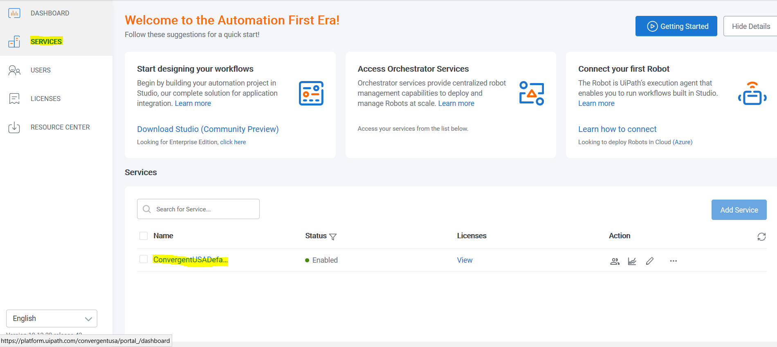

* Go To ‘**Management’** and select ‘**ROBOTS**’

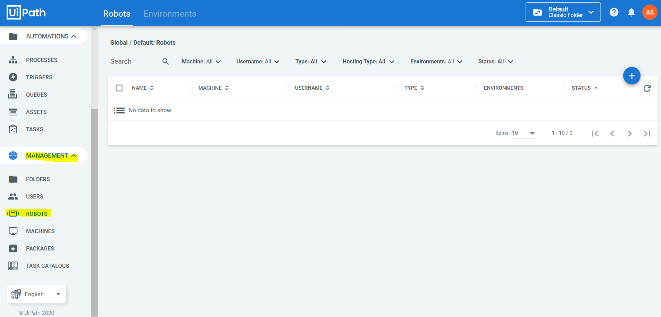

* Create robot by clicking on ‘+’ sign and creating robot of your choice (Standard OR Floating)

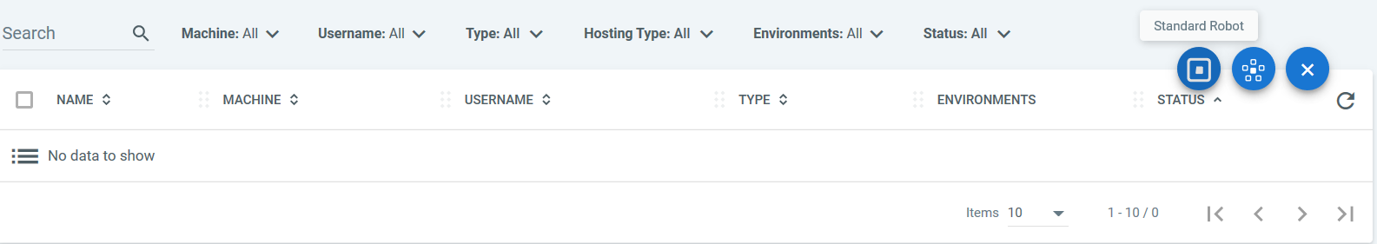

* When prompted for details fill in details highlighted in below image

Machine – can be extracted from ‘My Computer’ properties

Name – Fill in default name of your choice (can be anything)

Type – Studio

Domain\UserName – login username of your system

Password – Password used to log into your system

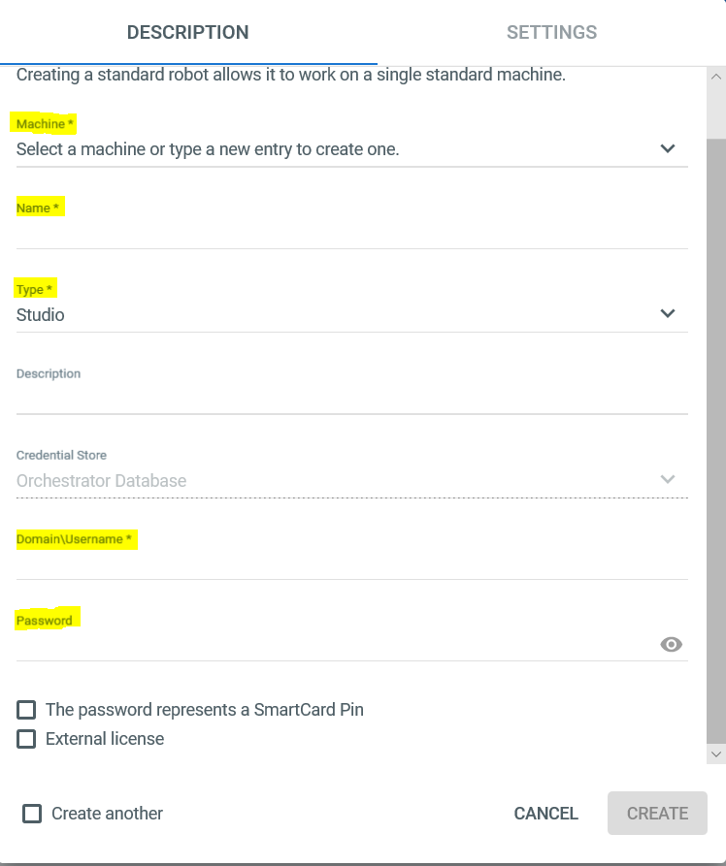

NOTE : This will create default machine in orchestrator and can be checked in Machines tab under Management.

* Go To ‘**Management**’ and select ‘**Machine**’ and click on option section of machine created and click Edit. Copy **machine key**  and close.

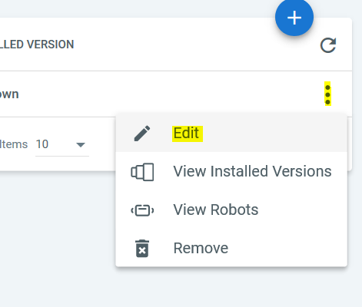

## **Bot provisioning with local system**

* Launch UiPath Robot
* Click on ‘**Orchestrator Settings**’

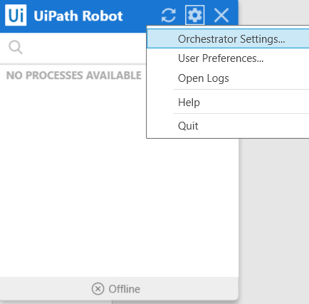

* Fill in **Orchestrator URL** : <https://platform.uipath.com> and **Machine Key :** copied using above steps from orchestrator. And click ‘**Connect**’. This will connect your orchestrator with your Local machine.

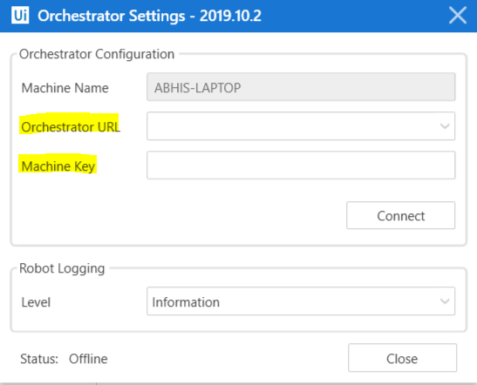

## **Activating UiPath using Orchestrator**

* Launch UiPath
* Select Acquire License from Uipath Orchestrator (as highlighted in below screenshot)

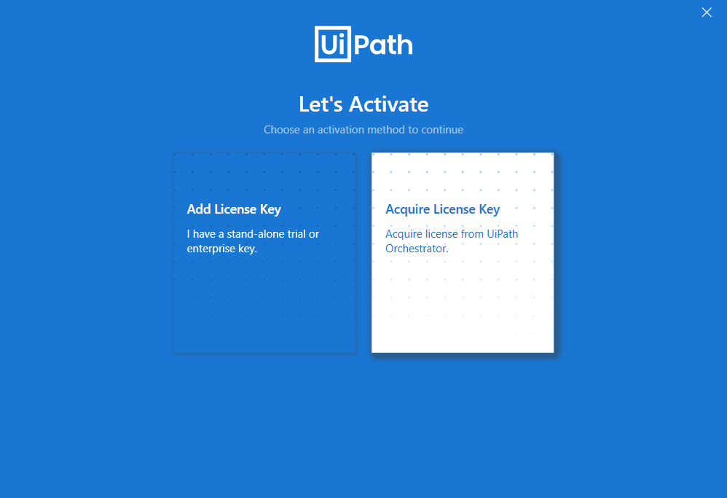

Now you Uipath is activated and ready to use.